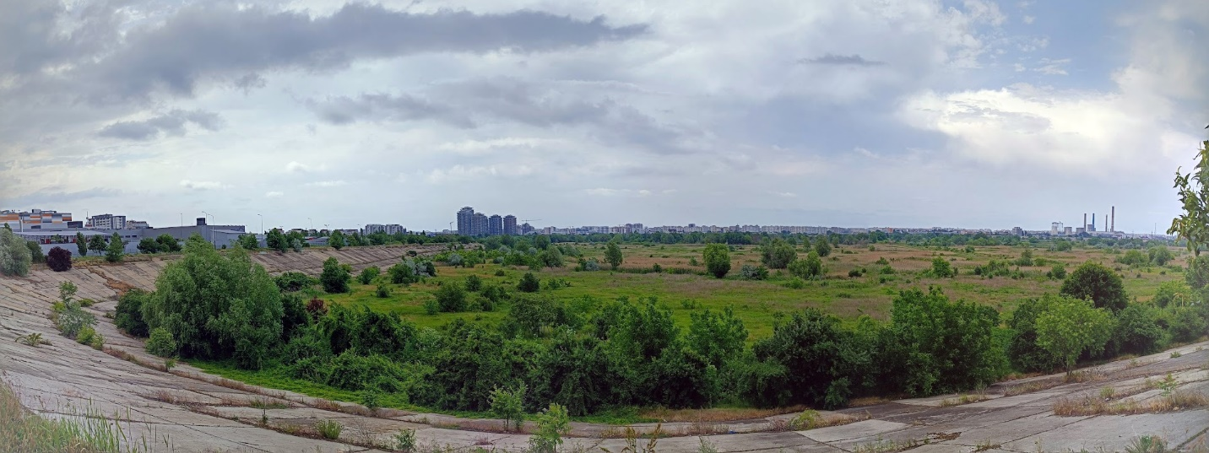
Participatory tools for urban nature planning and management
Extend your skills in participatory tools and learn more about how urban nature could be better planned and managed in diverse urban contexts
The inclusion of collaborative and multi-stakeholder initiatives for promoting urban sustainability is still rare, mostly derived from the general perception that this type of initiative slows down the decision-making processes due to a lack of consensus and different interests of stakeholders. This often leads to a confusing contribution of different stakeholders in the decision-making process (e.g., scientists, planners, private companies, public companies, NGOs, and citizens). However, public participation is a cornerstone of attending to urban sustainability, which needs consistent tools to be oriented in a constructive way. Urban nature, as a key component of urban green infrastructure, is considered a panacea for many societal challenges related to our cities, which could be considered as an excellent lab to experiment with ideas related to participation.
The course aims to discuss concepts, methodologies, and best practices related to participatory tools for urban nature planning and management. This will help the bachelor’s, master and Ph.D. students to understand better the challenges of public participation in urban areas.
Main addressed topics
Urban nature
Public participation
Participatory tools (e.g. GIS, Self-Organizing Maps, Content Analysis, Multicriteria Assessment, network analysis, Open Labs, Story Maps, Dashboards)
Learning outcomes
A critical understanding of the participatory tools for promoting urban sustainability
Practices related to public participation in different urban settings
Skills of using different tools for planning and management of urban nature
Understanding advantages and disadvantages of participatory tools in urban planning and management.
Professors
Professor Stefan Lang, Geoinformatics and Earth Observation, Paris-Lodron University of Salzburg
Professor Cristian Iojă, Environmental Sciences, University of Bucharest
Professor Mihai Niță, Geography, University of Bucharest
Associate professor Andreea Niță, University of Bucharest
Associate professor Diana Onose, GIS, University of Bucharest
Associate professor Athanasios Gavrilidis, Urban Planning, University of Bucharest
Professor María del Mar Alonso Almeida, Economy and Business, Universidad Autonoma de Madrid
Associate profesor Fernando Borrajo Millan, Economy and Business, Universidad Autonoma de Madrid
Period and location
Dates: 27 February 2023 - 30 June 2023 Language: English (B2)
Format: Blended ECTS: 3*
Location: Salzburg, Austria Workload: 80 hours
Contact: cristian.ioja@geo.unibuc.ro
* Recognition of ECTS depends on your home university.

Curricula
This course will be running from February 2023 to June 2023. It consists of the following:
February 2023 - Course 1 – Participation in urban sustainability
- Collaborative planning, sustainability, and participatory management.
- Forms of participation in urban planning, design, and management. European legislation - examples of countries' experiences in participatory practices. Public participation in territorial planning, water management, EIA, and SEA procedures.
- Who (what means public), when (regulations, administrative processes), and how (forms of participation) could participate?
- Expected impact of public participation
- Challenges of participation in urban planning
- Examples and impacts
March 2023 - Course 2 – Urban nature – open lab for participatory practices in urban areas
- Urban nature – connection with urban infrastructure
- Categories of urban nature and contribution to urban sustainability and resilience
- Main typologies of human–urban nature interactions in urban settings
- Ecosystems services trade-off and synergies. Specific users of urban nature.
- How could public participation be in urban nature planning and management?
April 2023 - Course 3 - GIS as a supporting tool for participatory management of urban nature
- Built/used of the GIS application for participatory management of urban nature.
- Existing participatory tools in practice (e.g. Green cadaster, local online platforms).
- From data collection to geo-visualization (story maps, dashboards, etc.)
- Integration of remote sensing data, Copernicus services, and other geospatial data
The suggested software to work is ESRI solutions.
May 2023 – Course 4 - Monitoring and evaluation of participatory practices in urban nature planning and management
- Criteria for monitoring and evaluation of participatory practices.
- Efficiency, efficacy, and performance of participatory practices
- Ethics of participatory management.
- Barriers and obstacles for participatory tools.

Online Roundtables February- May 2023
A dynamic, collaborative Online Learning Hub to facilitate exchange and document the results of the course
The main on-site learning course is envisioned to take place from 19 to 25 June 2023 in Salzburg
An Online Forum hosted on the Hub for student and staff collaboration and exchange throughout the project
The virtual part will be running from 27 February 2023 to 31 May 2023.

Roundtables: There will be a series of four online roundtable discussions in February, March, April, and May. The main goal of the roundtables is to establish a common ground for the course, as this is an interdisciplinary course including urban studies, ecology, geography, environmental sciences and GIS.

All sessions include group work and discussions with students.

Physical mobility
This course involves physical mobility to Salzburg, Austria, from 19 to 25 June 2023.
On-site Learning will take place in Salzburg. Teaching staff and students come together in Salzburg, Austria, to learn together.
The 5 days of intensive learning experiences focus on practical exercises, applications, and discussions. Teaching staff will give teaching input and lead smaller working groups dedicated to deepening the learning experiences.
These include:
- drawing lessons from interdisciplinary theoretical approaches and problematizing them in terms of practicability (case studies about urban participations, types of urban nature, interactions between stakeholders)
- building micro-projects related to participatory tools, related to GIS
- experimenting with existing tools for public participation in urban nature planning and management
- meet stakeholders from local governments, NGOs, private companies, administrations, and citizens, and learn about their interests, needs, and recommendations for public participation.
- participating in excursions to analyze the impact of public participation/less participation
Requirements
This course is open to Bachelor`s, Master's, and Ph.D.`s students at CIVIS member universities, with background-related fields e.g., environmental sciences, ecology, geography, sociology, economy, urban studies, or political science.

A B2 level of English is required.
Application process
Interested students should apply by filling in the online application form by November 2023.
Assessment
Learning will take place around blended formats of online teaching and the 5-day meeting:
Students will have to prepare to engage with the core readings for the roundtables and the on-site course. They will be required to formulate questions for facilitating the discussions and hand them in via the learning hub. They will also do a group presentation on a real-world problem at the on-site meeting.
Students participate in the experimental use of tools and techniques and reflect on their experiences in a short position paper
Students develop final documentation of their learning experience by contributing to the open repository (this could either be presentations, posters, podcasts, videos, or written reports). The teaching staff will advise students and examine the assignments. They will be evaluated according to each participating institution’s system.
Blended Intensive Programme
This CIVIS course is a Blended Intensive Programme (BIP): a new format of Erasmus+ mobility which combines online teaching with a short trip to another campus to learn alongside students and professors across Europe. Click here to learn more about CIVIS BIPs.
GDPR Consent
The CIVIS alliance and its member universities will treat the information you provide with respect. Please refer to our privacy policy for more information on our privacy practices. By applying to this course you agree that we may process your information in accordance with these terms.

