

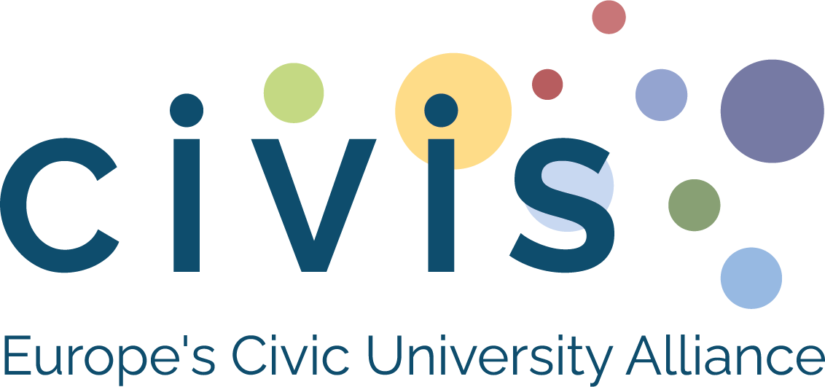

CIVIS Open Labs

C.I.V.I.S Sustainability Challenge:

an interdisciplinary learning initiative for real‑world impact

Version 2025-11-05


Context & Short Description
The C.I.V.I.S. (Creative, Innovative, Visionary, Interdisciplinary, and Socially responsible) Sustainability Challenge (or CSC) is an interdisciplinary, challenge-based learning experience connecting university resources towards developing impactful solutions to real-world challenges. Developed within the European Civic University Alliance, it is coordinated by the Université libre de Bruxelles and implemented at 6 partner universities in Europe and Africa.
The project addresses the growing need for hands-on, socially responsible education that bridges teaching, research, and societal impact. It engages students from diverse disciplines to work alongside local stakeholders, such as NGOs, municipalities, and civil society organisations, in an intensive 48-hour challenge, combining academic knowledge, civic engagement, and innovation. Promising solutions will be encouraged to further develop through incubators and mentoring programmes, and Open Labs.
Part of the Open Labs, the Challenge provides a scalable model for interdisciplinary, participatory learning across the CIVIS Alliance.

Partners

Partner Name | Type (academic, non-academic stakeholders, students, …) | Bio (2–3 lines) | Photo/Logo
Université libre de Bruxelles | Academic | The Université libre de Bruxelles (ULB) is a leading research-intensive university committed to critical thinking, academic freedom, and social responsibility. Through its teaching and research activities, ULB actively contributes to interdisciplinary approaches addressing contemporary societal challenges, including sustainability, environmental responsibility, and education for social change. | 
National and Kapodistrian University of Athens | Academic | The Environmental Education Lab (EEL), based in the Department of Educational Studies, School of Philosophy, at the National and Kapodistrian University of Athens (NKUA), is a research and academic hub advancing knowledge and critical engagement in Environmental and Sustainability Education. | 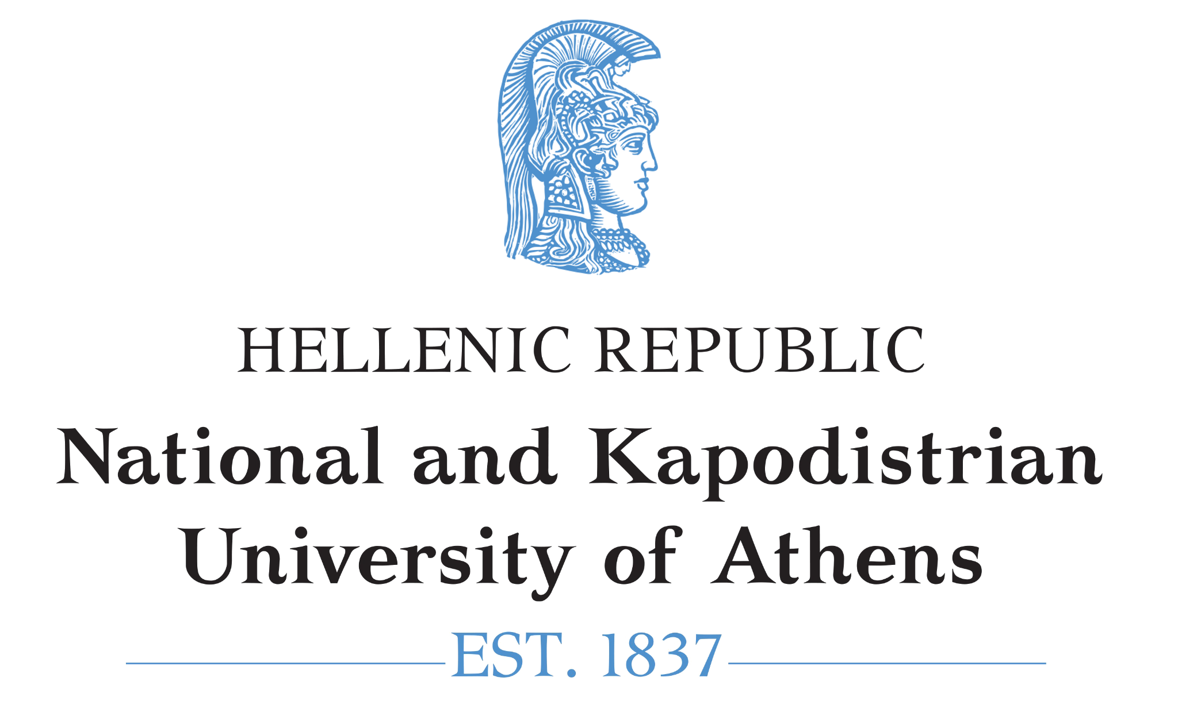
Universidad Autónoma de Madrid | Academic and Stakeholders | UAM is a leading public research university committed to academic excellence, innovation, and social responsibility, with a strong focus on interdisciplinary approaches to sustainability, inclusion, and social transformation. Tangente is a cooperative group that promotes sustainability and ecosocial transformation through the social economy and inter-cooperation. | 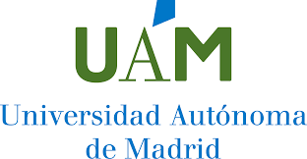
University of Glasgow | Academic and non-academic | Combination of Glasgow Goes Green Week (at UofG), CfSS, ARC, and others. | 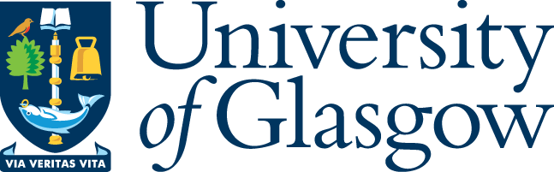
Makerere University Kampala- Uganda | Academic, Government and NGO’s, Donors, | Government owned with a population of about 80,000with all disciplines. | 

Main Beneficiaries & Social Impact

Main Beneficiaries
- Students (final-year bachelor’s, master’s, and postmaster’s) from all disciplines at CIVIS partner universities.
- Local stakeholders (NGOs, municipalities, social enterprises, community organisations) involved in defining and evaluating challenges.
- Academic staff and researchers engaged in interdisciplinary teaching and participatory research.
Participation takes place through open calls, preparatory learning modules, onsite 48-hour challenges, mentoring sessions, and a hybrid inter-university final. Approximately 20–50 students per university are typically involved in local challenges, with finalists advancing to the final CIVIS-wide event.

Social Impact
The CSC strengthens sustainability skills, teamwork, leadership, and ethical reasoning among student participants, while fostering civic engagement and cross-cultural collaboration. For stakeholders, it delivers fresh ideas, actionable solutions, and stronger university–community partnerships. At the institutional level, it contributes to curricular innovation and scalable models for challenge-based learning, reinforcing CIVIS Open Labs’ mission to cocreate knowledge with and for society.

Core Methodology

The CSC uses a Challenge-Based Participatory Learning approach, combining interdisciplinary teamwork, stakeholder cocreation, real world case studies, mentoring, and reflective practice. Students work on authentic sustainability challenges through intensive workshops and prototyping, supported by academic, professional, and civic partners.

Events in the Project

Event Name | Date(s) | Location | Description (purpose, audience)
Open Lab Brussels  Sustainability Challenge | 20 and 21 March, 2026 | Open Lab Brussels, Usquare campus | 48-hour hackathon for selected students from ULB
CIVIS Sustainability Challenge at UofG | 6 and7 March | Advanced Research Centre (ARC), University of Glasgow | 2-day hackathon for students from Glasgow
Sustainability Challenge at UAM | 2 & 9 March | Cantoblanco Campus | 2-day activity for selected students from UAM
NKUA Sustainability Challenge | 27 & 28 March  2026
Makerere University Uganda | 5–7 March 2026 | Innovation & Invention Centre | Two days activity in the Innovation Lab

Deliverables & Resources

Deliverable / Resource | Type (report, video, toolkit…) | Link / File | Caption / Description
Written document and final presentation | Written work submitted to the jury may be of any kind, but the presentation is limited to 3 minutes followed by a 10-minute exchange with the jury

Testimonials & Highlights

A. Key Take-Aways / Highlights
- Interdisciplinary and international student teams addressing real societal challenges.
- Strong collaboration between universities and local stakeholders.
- Hybrid local-to-global format reducing environmental footprint.
- From ideas to impact: follow-up support through incubators and fab labs.
- Replicable model aligned with CIVIS Open Labs and UN SDGs.

B. Beneficiary Impressions / Quotes
“The CIVIS Sustainability Challenge allowed me to apply my studies to a real problem while collaborating with students from completely different backgrounds.”
— Student participant
“Working with students brought fresh perspectives to our sustainability challenge and opened new paths for collaboration with the university.”
— Local stakeholder partner
“This project shows how challenge-based learning can genuinely connect education, research, and societal impact.”
— Academic coordinator

Contact Point

At the Université libre de Bruxelles:
Name: Sandra Rothenberger and Jean-François Desoutter
Email: sandra.rothenberger@ulb.be; jean-francois.desoutter@ulb.be
Institution / Role: Main academic and administrative coordinators of the CSC

At the Universidad Autónoma de Madrid:
Name: Leyla Angélica Sandoval Hamón and Alfonso García de la Vega
Email: angelica.sandoval@uam.es; alfonso.delavega@uam.es
Institution / Role: Co-coordinator for CSC at UAM; Director of University Institute of Education Science, UAM

At the University of Glasgow:
Name: Timothy Peacock
Email: Timothy.Pecock@glasgow.ac.uk
Institution / Role: Director of Games and Gaming Lab (UofGGamesLab), University of Glasgow

At the National and Kapodistrian University of Athens:
Name: Maria Daskolia
Email: mdaskol@eds.uoa.gr
Institution / Role: Director of Environmental Education Lab - Department of Educational Studies / Academic Coordinator for CSC at NKUA

At Makerere University

Name : Anthony Tibaingana
Email: atibaingana@gmail.com or anthony.tibaingana@mak.ac.ug
Tel: +256-702-134-978

