Third Call for Proposals for CIVIS Hub 1

Activities: *Climate, Environment and*

*Energy*

*The deadline for this call is* ***October 15, 2021.***

**1. CONTEXT - A challenge-based approach to fuel our civic, impact-driven Alliance**

**CIVIS European University Alliance** is a far-reaching initiative whose goal is to have a significant impact on our societies’ development, locally and globally. We will intertwine relationships at all scales with a wide diversity of stakeholders, in order to implement educational and research activities grounded in our fast-changing ecosystems.

**Five major challenges (“Hubs”)** of local and global reach lie at the core of our actions: Climate, Environment, Energy; Health; Digital and Technological Transformations; Cities, Territories, Mobilities; Society, Culture, Heritage.

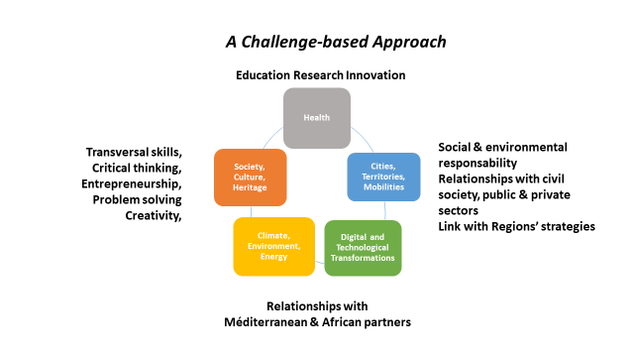

**CIVIS Hubs** are “academic collaboration spaces” to develop multinational and multi-disciplinary educational and research offers. They will be offering joint degrees, innovative learning practices and blended mobility at Bachelor’s and Master’s levels, multidisciplinary research programs as well as public and/or private partnerships. CIVIS Hubs will remain at the forefront of civic engagement, maintaining the **“challenge-based” approach** to ensure that the European University remains relevant and useful to society, addressing new challenges as they arise.

**CIVIS Hubs will support academics** willing to contribute to tackle these challenges together with other European colleagues and involve respective staff, faculty and researchers of the 9 member universities to work in **multidisciplinary teams to develop joint degrees, educational programs and research projects, using innovative pedagogies.** During the first phase of CIVIS Alliance, Hubs will be on developing a ‘surge’ of collaborations, which will be strategized during the consolidation phase.

The added value of being part of CIVIS Hubs means being included in **nests to innovative educational programs linked to research and innovation**, address issues from a multidisciplinary and complementary perspective, develop high-level and multidisciplinary research collaborations. CIVIS Hubs will provide you access to a network of motivated lecturers and researchers from CIVIS universities ready to revolutionize the current higher education system and contribute to our societal challenges.

**2. HUB 1 CLIMATE, ENVIRONMENT, ENERGY – THIRD CALL FOR ACTIVITIES**

You will find below the third call for activities launched by the Hub 1 Climate, Environment, Energy.

We welcome proposals for education and research activities. Our objective is to **foster synergies among Education and R&I**. We are especially looking for allied programs, allied semesters and allied courses and course packages at Bachelor, Masters and PhD levels. We also welcome proposals for short courses, summer schools, workshops, project supervision and research exchanges. The proposed activities could include training & research projects with students as well as workshops/meetings of academic staff to develop future joint academic & research activities.

We welcome proposals which are “**ready to go**” preferably before the end of 2022 and that comply with the “must be fulfilled” criterion below. These include initiatives that open up existing programs, semesters and courses at partner universities for academic collaboration within CIVIS. For all approved activities we can offer **CIVIS branding, networks and support** as well as **student and staff mobilities**. There are also some funds for academic staff (see below).

The following criterion must be fulfilled (Eligibility criterion):

* Activities must involve 3 or more CIVIS partner universities.

The following criteria will be prioritized (Evaluation criteria):

First tier evaluation criteria

While we continue to encourage proposals for short courses, summer schools, workshops, project supervision and research exchanges, we will prioritize:

* Allied programs  
  This is a program at Bachelors, Masters or PhD level in which 3 or more CIVIS partners are co-teachers for the majority of courses. This can be an existing program at a CIVIS partner which includes a majority of courses which are modified to include co-teachers from an additional 2 or more CIVIS partners.
* Allied semesters  
  This is a semester or “micro-program” at Bachelors, Masters or PhD level in which 3 or more CIVIS partners are co-teachers for several courses. This can be an existing semester at a CIVIS partner that includes several courses which are modified to include co-teachers from an additional 2 or more CIVIS partners.
* Allied courses  
  These are courses or packages of courses which a student can use as part of her/his education at Bachelors, Masters or PhD level in which 3 or more CIVIS partners are co-teachers. These can be existing courses at a CIVIS partner which are modified to include co-teachers from an additional 2 or more CIVIS partners.

We are aware that program, semester and course structures differ considerably between our partner universities and we stress that all types of courses that can be accredited to student’s degree are welcome.

Second tier evaluation criteria

We will also prioritize:

* Virtual activities (for environmental reasons).
* Transdisciplinary challenge-based activities (i.e. involving non-academic partners).
* Civic engagement initiatives tied to Open Lab (WP3) activities.
* Academic initiatives for which Mediterranean/African partners have been identified with assistance from WP5.
* Academic initiatives which also stimulate research collaboration.

Hub 1 initiatives are organized into a framework which is partly based on focal challenges defined by Future Earth (<https://futureearth.org/wp-content/uploads/2019/03/future-earth_10-year-vision_web.pdf>). This framework encompasses **research-oriented education** and **knowledge-action education** pathways that target the following focal challenges:

1. Deliver energy, water, and food for all

2. Decarbonise socio-economic systems to stabilise the climate

3. Safeguard the terrestrial, freshwater and marine natural assets

4. Increase resilience and promote sustainable transformations

5. Create fundamental knowledge about climate, environment and energy

The Hub 1 Council will make final recommendations to the CIVIS Board of Rectors as to which courses and/or activities will become a part of Hub 1. This Council will be using the criteria outlined above when making its recommendations.

If you need support for finding partners or guidance on CIVIS approach, please contact one of the Hub 1 Council members at your university or the chairperson of the Hub 1 Council. Please find below the list of Hub 1 Council members:

Chairperson – Alasdair Skelton ([alasdair.skelton@geo.su.se](mailto:alasdair.skelton@geo.su.se))

Athens - Christina Anna Mitsopoulou ([cmitsop@chem.uoa.gr](mailto:cmitsop@chem.uoa.gr))

Brussels - Lei Chou ([lei.chou@ulb.ac.be](mailto:lei.chou@ulb.ac.be)) and Pierre Regnier ([pierre.regnier@ulb.ac.be](mailto:pierre.regnier@ulb.ac.be))

Bucharest - Delia-Laura Popescu ([delia.popescu@chimie.unibuc.ro](mailto:delia.popescu@chimie.unibuc.ro)) and Laura Comănescu ([laura.comanescu@unibuc.ro](mailto:laura.comanescu@unibuc.ro))

Glasgow – Jaime Toney ([jaime.toney@glasgow.ac.uk](mailto:jaime.toney@glasgow.ac.uk))

Madrid - Enrique Michel ([enrique.garcia.michel@uam.es](mailto:enrique.garcia.michel@uam.es)) and Juan Malo ([je.malo@uam.es](mailto:je.malo@uam.es))

Marseille - Anne Cadoret ([anne.cadoret@univ-amu.fr](mailto:anne.cadoret@univ-amu.fr)) and Jerome Rose ([rose@cerege.fr](mailto:rose@cerege.fr))

Rome - Donatella Magri ([donatella.magri@uniroma1.it](mailto:donatella.magri@uniroma1.it)), Fausto Manes ([fausto.manes@uniroma1.it](mailto:fausto.manes@uniroma1.it)) and Livio De Santoli ([livio.desantoli@uniroma1.it](mailto:livio.desantoli@uniroma1.it))

Stockholm - Miriam Huitric ([miriam.huitric@su.se](mailto:miriam.huitric@su.se)) and Fredrik Oldsjö ([fredrik.oldsjo@su.se](mailto:fredrik.oldsjo@su.se))

Tübingen - Christiane Zarfl ([christiane.zarfl@uni-tuebingen.de](mailto:christiane.zarfl@uni-tuebingen.de)) and Todd Ehlers ([todd.ehlers@uni-tuebingen.de](mailto:todd.ehlers@uni-tuebingen.de))

Student representatives - Julika Zinke ([Julika.zinke@aces.su.se](mailto:Julika.zinke@aces.su.se)) and Elis Wibacke ([v.ordforande@sus.su.se](mailto:v.ordforande@sus.su.se))

To help you find about more about CIVIS, find partners and find out more about proposing activities, we invite you to an **Educators Networking Meeting** on September 3, 2021 from 10:00 to 12:00 CET. This online meeting is for anyone who is involved in educational activities at all levels (Bachelors, Masters, PhD) in and anyway who wants to find out more about getting involved in CIVIS Hub 1 (Climate, environment and energy). More information can be found at URL_address.

Also, please refer to the lists of approved CIVIS activities for further inspiration. This can be accessed at URL_addresses.

Proposals must be submitted using the template on the following page.

Please submit the completed application **before October 15, 2021** at URL address

**THIRD CALL FOR HUB 1 ACTIVITIES – APPLICATION FORM**

|  |  |
| --- | --- |
| Title of the proposed activity: |  |
| Name & contacts of the coordinator: |  |

|  |  |
| --- | --- |
| Participant universities & contacts (minimum of 2 other CIVIS universities): |  |

|  |  |
| --- | --- |
| Dates when activity will be offered for the first time (please be as specific as possible, activities which will start during 2022 will be prioritized) |  |

**Activity type**

|  |  |  |  |
| --- | --- | --- | --- |
| Type of activity | Physical mobility  *(includes physical travel to another country)* | Virtual mobility  *(NO travel involved)* | Blended mobility *(short-term physical mobility combined with “virtual mobility”)* |
| Allied program* |  |  |  |
| Allied semester* |  |  |  |
| Allied course* |  |  |  |
| Short course |  |  |  |
| Summer schools |  |  |  |
| Workshop |  |  |  |
| Project supervision |  |  |  |
| Research exchanges |  |  |  |
| Other (please specify): |  |  |  |

* Please refer to call text for definitions of “allied program, semester and course”.

|  |  |  |  |
| --- | --- | --- | --- |
| Type of mobility foreseen | Physical mobility  *(includes physical travel to another country)* | Virtual mobility  *(NO travel involved)* | Blended mobility *(short-term physical mobility combined with “virtual mobility”)* |
|  |  |  |

|  |  |  |  |
| --- | --- | --- | --- |
| Capacity (total # of participants): |  | Number of ECTS credits  (educational activities only): |  |
| Education Level/Cycle (Bachelor/Master/PhD) | |  | |
| Language of the activities | |  | |

**Description**

|  |
| --- |
| Summary of the activity: |
| Description of the activity (Aims, Scopes, Content, Learning outcomes etcetera): |

**Pathway**

|  |  |
| --- | --- |
| Pathway (“research-oriented education” or “knowledge-action education”): |  |
| Motivation (please motivate your choice of pathway): | |

**Focal challenge**

|  |  |
| --- | --- |
| Focal challenges (please enter one or more of the 5 aforementioned focal challenges): |  |
| Motivation (please motivate your choice of focal challenge): | |

**Prioritization**

|  |
| --- |
| Please motivate how your proposal meets the criteria for tier 1 prioritization (joint program, joint semester, joint course): |
| Please motivate how your proposal meets the criteria for tier 2 prioritization (Virtual mobility, transdisciplinary challenge-based activity, connection to Open Labs, involvement of Mediterranean/African partners; education activity that stimulates research collaboration): |

**Funding needs**

Proposals for activities with start dates in 2022 will be prioritized for staff and student mobility funding as well as “staff incentives” (see below) from CIVIS.

|  |
| --- |
| If funds are needed, please provide (1) an estimation of the number and duration of expected staff and/or student mobilities (e.g. 20 travelling students for seven days) of the activities, and (2) an estimation of costs for “staff incentives”. |
| If funds are needed, please provide a motivation related to the objective of the proposal, the nature of the activities implemented during the mobility period and the persons involved: |

\****CIVIS can provide financing for mobility costs*** *(travel cost + allowances) for academic staff for a short-term duration (max 1 week)* ***and for staff “incentives”*** *(see below). The eligible activities for funding should be related to implement joint academic/research activities and/or meetings/workshops of academics to develop future activities. CIVIS does not provide funding for other staff costs.*

**APPENDIX**

**Eligible costs & calculation for CIVIS budget**

***Eligible Costs for CIVIS Mobilities***

* CIVIS could only finance travel cost and allowances for students and/or academics staff for short term mobility (max 1 week)
* The student mobility will be financed according to the unit cost established in CIVIS Consortium Agreement (see next section)
* The student mobility activities must include learning outcomes for the participants
* The academic staff mobility could include training activities with students and activities to develop future joint academic & research initiatives
* The academic staff mobility will be financed according to each institution usual practices
* Limitations as to the numbers of funded mobilities of students or academic staff may apply, subject to availability of funds.
* CIVIS budget will directly finance only mobilities currently not eligible under other Erasmus+ actions.

Please note: The academic participants may also cover their travel and accommodation costs through Erasmus+ mobility programs [Staff Teaching Mobility](https://ec.europa.eu/programmes/erasmus-plus/opportunities/individuals/staff-teaching/higher-education_en). This budget for staff mobility is available in each partner university. Likewise, for student mobility there are several eligible options within [Erasmus+ program](https://ec.europa.eu/programmes/erasmus-plus/opportunities/students_en). Therefore, CIVIS before validating the direct funding of the proposed activities will verify the eligibility under other actions of existing European funding programs.

***Eligible Costs for Staff***

* CIVIS can finance staff costs (‘incentives’) related to the implementation of activities, in particular the development of programs and degrees, according to each university’s internal regulations, to the allocated budget and to a funding framework binding for each hub.
* Funding of staff costs is to be allocated to the development of physical, virtual or blended courses, modules and programs and cannot be used for mobility costs (travels and subsistence).
* The Hub Council and the Steering Committee will select and accept the budget corresponding to the quality and level to reach CIVIS objectives. The Hub Council may decide if all universities participating in an activity will get an equal maximum amount or if the coordinator of a project will get additional funds. Funding per activity could range between 1000 and 8000 €.
* Each CIVIS University involved should validate the project and staff costs before start. The university responsible for coordinating the activity is also in charge of financial reporting unless otherwise agreed.
* All staff costs must follow reporting rules of the European Commission: real costs and timesheets need to be provided to prove the work and a direct link to the project’s activities and objectives.

**STUDENT MOBILITY BUDGET CALCULATION**

* Travel costs and individual support for student short term and blended mobility activities are based on unit costs as an internal rule applying to all the beneficiaries.
* These unit costs are based on Erasmus + 2020 program guide and are the following:
  + *Travel costs* based on the travel distance per participant: travel distances must be calculated    using the distance calculator supported by the European Commission (<http://ec.europa.eu/programmes/erasmus-plus/tools/distance_en.htm>).
  + The distance of a one-way travel must be used to calculate the amount of the EU grant that will support the round trip.

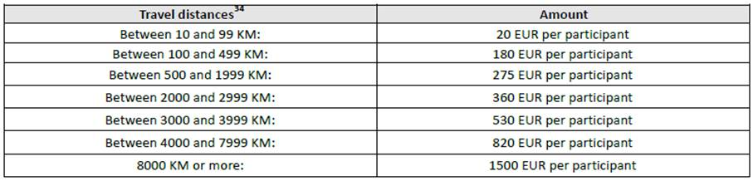

|  |
| --- |
| * *Individual support*based on the duration of the stay per participant (if necessary, including also one travel day before the activity and one travel day following the activity). |
|  |

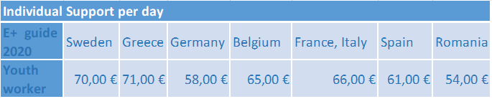

**No CIVIS equipment budget is allocated for digital mobility/activities.**

**Limitations as to the numbers of funded mobilities of students may apply, subject to availability of funds.**