Rectors meeting 10 May with Commissioner Gabriel on higher education package

Roundtable with rectors of European Universities on the higher education package
As a follow-up to our save-the-date and invitation from February, we confirm the online Roundtable with rectors of European Universities on the higher education package, in the presence of Commissioner Gabriel, on 10 May 2022 from 09.30 to 11.00 am.
As per usual practice, one rector per European University is invited to join. You may find enclosed the agenda and connection details, as well as some background information, including guiding questions for the discussion.
A rector per European University will represent the alliance as a whole. 20 out of the 41 rectors/presidents will intervene and take the floor for a maximum 3 minutes intervention. You will receive from the EC the proposed distribution of the speaking slots, taking into account geographical balance and gender considerations.
To facilitate information sharing, also 2 representatives from the coordinators of the European Universities alliances will join : representatives of FOR-EU1 and FOR-EU 2 networks.

Bio Commissioner Gabriel
Mariya Ivanova Gabrie is a Bulgarian politician and a member of the GERB party serving as European Commissioner for Innovation, Research, Culture, Education and Youth since 2019. She served as Member of the European Parliament (MEP) from 2009 to 2017.
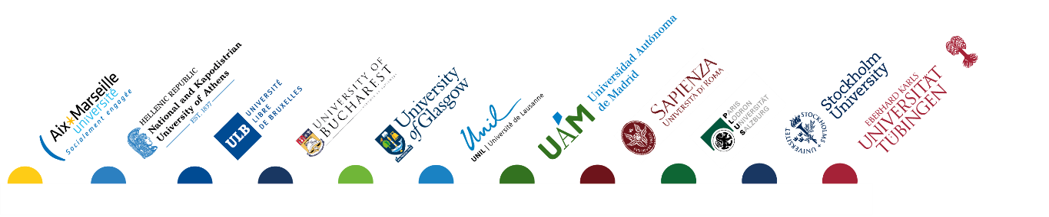
In the European Parliament she served as Vice-President of the European People’s Party (EPP) group, Vice-President of EPP Women and head of the Bulgarian EPP delegation. She was first appointed to the European Commission in 2017 as European Commissioner for Digital Economy and Society to fill a spot left vacant by the departure of Kristalina Georgieva.

Responsibilities Innovation, Research, Culture, Education and Youth
- Ensuring swift agreement on, and full implementation of, the future Horizon Europe programme.
- Ensuring investment flows for disruptive research and breakthrough innovations, including through the European Innovation Council.
- Developing the European Research Area in cooperation with Member States.
- Ensuring integration between research and economic priorities.
- Leading the Commission’s work on a European Education Area by 2025.
- Promoting excellence and networking among European universities and implementing the European University Initiative.
- Updating the Digital Education Action Plan and raising awareness of disinformation and other online threats.
- Ensuring full implementation of the New European Agenda for Culture, promoting creative industries and promoting the Creative Europe Programme.
- Promoting sport for inclusion and well-being, expanding the #BeInclusive EU Sports Awards and the European Week of Sport.
- Strengthening international cooperation in education, research, innovation and culture.

