CIVIS E-MAIL SIGNATURES AND SETUP

We have created two templates which will allow you to CIVIS brand your email signature. If you work entirely in a CIVIS-level role, we invite to use the first template. If you work at member-university level and wish to combine CIVIS branding with your local branded signature, we invite you at add the second template below your existing signature.

FULL SIGNATURE
If you do not wish to include a phone number, delete | phone number.

SURNAME Name
Title
CIVIS, Europe’s Civic University Alliance
University – City, Country
mail@email.com | phone number

MEMBER SIGNATURE

INSTALLATION GUIDELINES - OUTLOOK
Copy the signature which you wish to use. Note that they are designed in HTML tables, and you should copy the whole table to ensure that the signature displays correctly.

For the full signature you should create an entirely new signature.
Go to Home > New email.

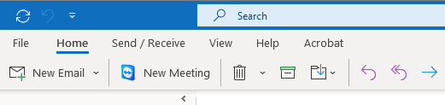

In the New Email panel, click on Signature > Signatures…

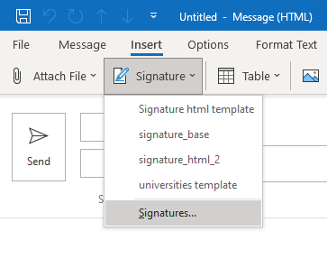
This window will open.
Click on New and type a name for your signature.

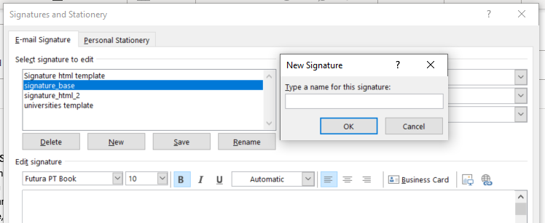

Paste your CIVIS signature in the Edit signature panel.
Write your name, title, university, city, country e-mail address, and phone number where and if needed. Save and click on OK.
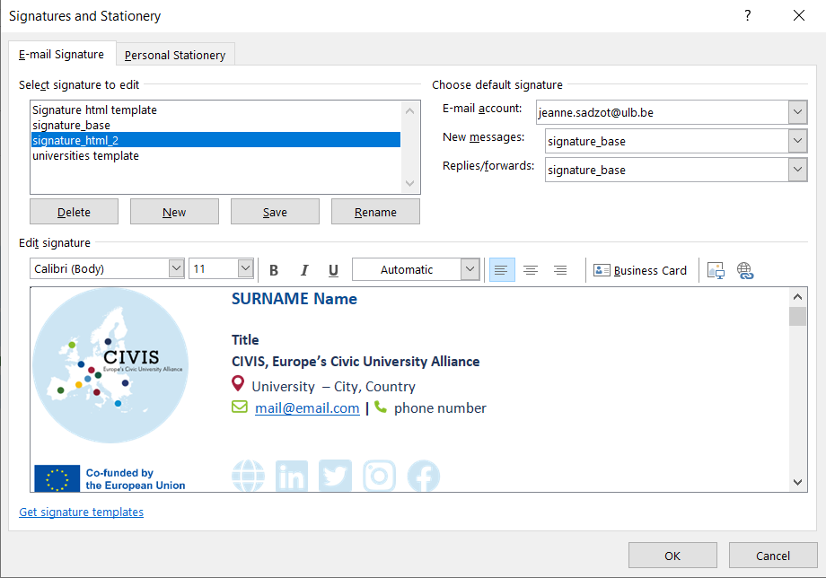

For the member signature you should edit your existing signature, adding the table below your contact details and university branding.

To use the signature, go back to the New Email window and choose the newly created or updated signature.

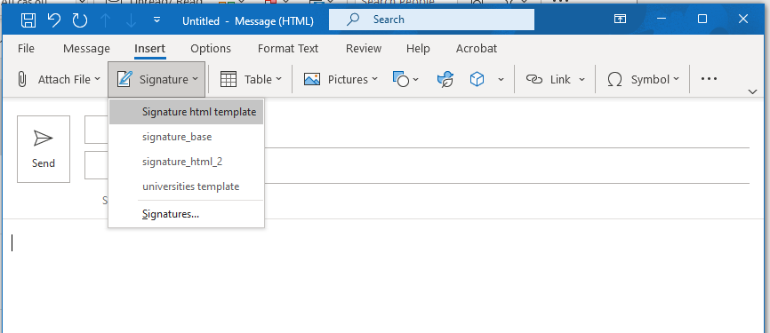

Your CIVIS signature will now appear !

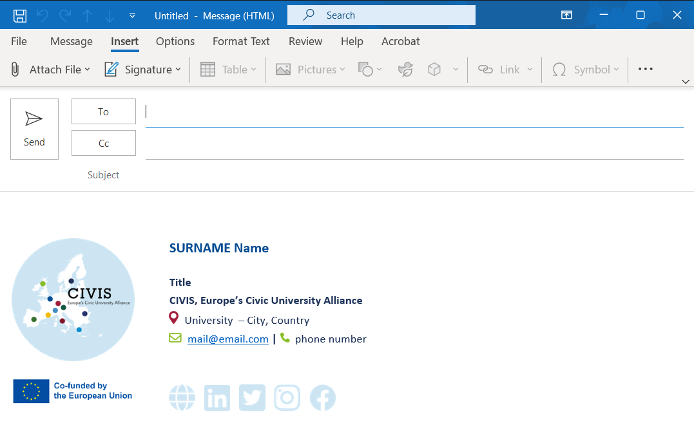

You may wish to set this signature as your default, so that it automatically appears on all your new emails.

