

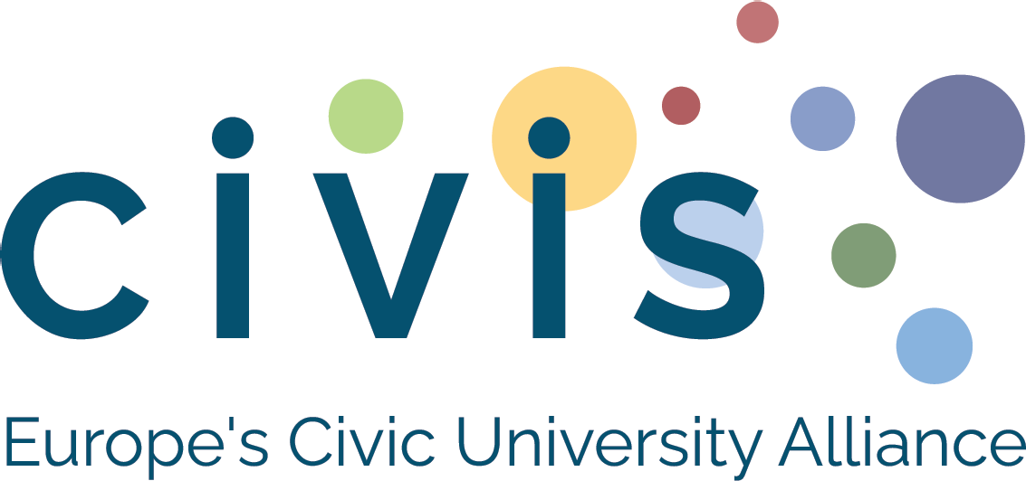

CIVIS Days 2026
Application form for dissemination sessions proposals
“CIVIS is News – seven years of shared impact”
June 2026 | University of Bucharest

About the 2026 edition
In 2026, CIVIS celebrates seven years of collaboration, innovation, and transformation as a European University Alliance. Under the theme “CIVIS is News – seven years of shared impact”, this edition will highlight stories, results, and lessons learned across the Alliance, from joint educational initiatives and mobility schemes to civic engagement, inclusion, and academic collaborations.
CIVIS Days 2026 will serve as a space to share, reflect, and inspire, turning experiences from the past seven years into ideas and actions for the future.

Purpose of the call
We invite academics, researchers, administrative staff, students, and partners from the CIVIS community to propose interactive dissemination sessions that:
- Showcase results, lessons learned, or innovative practices from CIVIS collaborations or projects;
- Involve at least 3 CIVIS universities;
- Target at least 2 participant groups (academics, researchers, staff, students, partners, or civil society);
- Fit within a 1h45 fixed slot;
- Have a clear objective or tangible outcome (e.g. shared reflection, transferable methodology, collaboration roadmap).

Session formats
1. Interactive workshop
For dialogue, co-creation, and shared learning. Examples:
- World Café – participatory discussion tables
- Co-development / co-vision workshop – collaborative design of concepts
- Problem-solving session – addressing shared challenges collaboratively
- Other interactive format – describe your idea
2. Dissemination / teach & share session
For presenting and exchanging results or best practices in an engaging way. Examples:
- Panel discussion – 2-3 speakers + moderator)
- Fishbowl – dynamic, audience-integrated conversation
- World café for dissemination – rotating tables for results sharing
- Other dissemination-oriented format – describe your proposal
3. Other innovative formats
Open formats such as storytelling, exhibitions, pitch sessions, or creative demonstrations inspired by “CIVIS is News”.

Selection criteria
Proposals will be assessed based on:
- Involvement of at least 3 CIVIS universities;
- Engagement of at least 2 participant groups (audience categories);
- Clarity and coherence of objectives and structure;
- Potential to inspire and inform other CIVIS stakeholders;
- For the dissemination sessions, focus on showing results, methodologies, or lessons learned
- Relevance to the 2026 theme “CIVIS is News”
- Feasibility within the 1h45 slot.

Submission details
Deadline for proposal submission: 19th of December 2025
Notification of selected sessions: end of January 2026
Contact: civis@unibuc.ro

Application form
Before You Begin
Please complete all sections clearly and concisely.
Proposals should emphasise collaboration, dissemination, and impact across CIVIS and the broader higher education community.
If you are unsure which CIVIS body or audience your session fits best, please contact your CIVIS Office at your university for guidance.
You may attach supporting materials (poster draft, short outline, or sample slides) if relevant.
Section 1. Contact information
Name and surname (open text)
Email address (open text)
Home university (drop-down list of all CIVIS universities)
Role in home university (if any) (open text)
Role in CIVIS (if any) (open text)
Type of participant (academic / researcher / staff / student / partner) (multiple-choice question)
Section 2. Session overview
Session title (open text)
Type of session (Interactive Workshop / Dissemination Session / Other) (single-choice question)
Topic and relevance to “CIVIS is News” (open text)
Objectives (max 150 words) (open text)
CIVIS Priority Area(s) addressed (tick all that apply): (multiple-choice question)
- Climate, Environment & Energy
- Society, Culture & Heritage
- Health
- Cities, Spaces & Mobilities
- Digital & Technological Transformation
- Other (please specify)
Expected output (choose one or more): (multiple-choice question)
- Synthesis note / short report
- Visual or communication piece (poster, infographic, video –materials designed after session, no later than the end of July)
- Joint project idea or follow-up meeting
- Policy or practice recommendation
- Other (please specify)
Is this session linked to a previous CIVIS initiative, project, or activity? If yes, please specify (project name or short description). (single-choice question + open text if “Yes”)
- Yes
- No
Section 3. Session details
Short description (max 200 words) (open text)
Structure of the activity (main steps or segments, suggestion: 800-2000 words) (open text)
Methodology / format description (open text)
Speaker(s) / moderator(s) (name and short profile) (open text)
Rapporteur (name or role) (open text)
Universities involved (minimum 3 CIVIS universities) (drop-down list of all CIVIS universities with multiple-choice selection)
CIVIS body or entity to which this session would be most relevant / addressed. Examples: HUBs, Units, Expert Groups, Education Council, Governance bodies, Communication teams, Student Council, etc. (open text)
Other partners / external stakeholders (if any) (open text)
Target participants (students / academics / researchers/ staff / partners / other) (multiple-choice question)
Expected number of participants (the ideal number or range for the proper organisation of the session) (open text)
Technical needs (room setup, materials, hybrid tools, etc.) (open text)
Section 4. Visibility and communication
Do you agree for your session to be featured in the official CIVIS Days 2026 programme and communication materials (online and print)? If “No”, please motivate your option. (single-choice question + open text if “No”)
- Yes
- No
Do you agree for your session to be recorded during the event and used for future CIVIS purposes after the event? If “No”, please motivate your option. (single-choice question + open text if “No”)
- Yes
- No
Propose a post-event dissemination activity that includes relevant aspects of your session (e.g. inspiring story highlighting a result or impact; share an innovative practice, the societal impact of what was presented in the session, explaining its narrative potential for written or audiovisual content, max 200 words) (open text)
Section 5. Additional information
Additional comments or notes for the organisers: (e.g. accessibility needs, collaboration with another European University Alliance, preferred time slot, other remarks) (open text)

