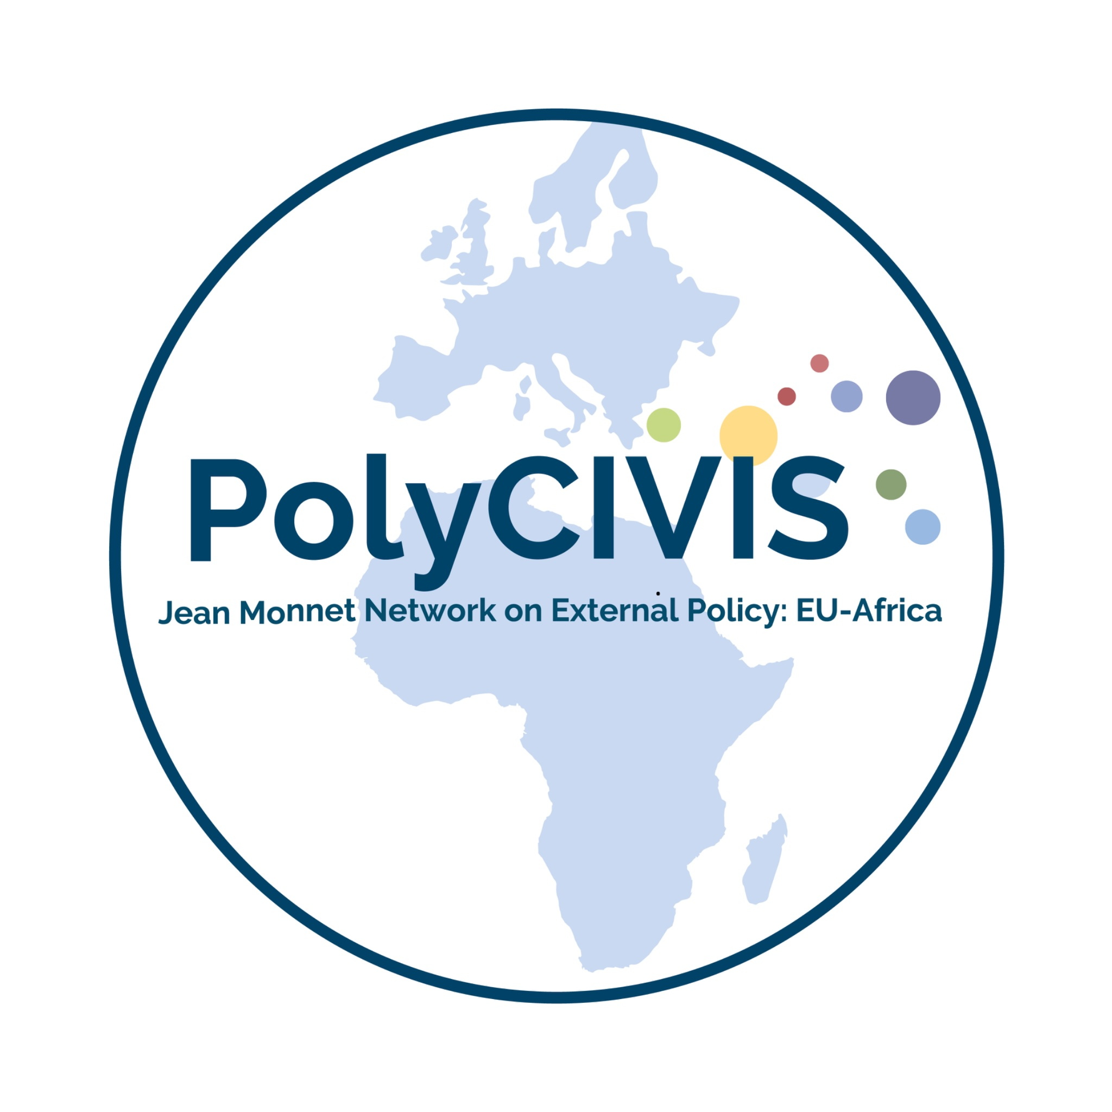

Call for Policy Briefs: Polycrisis and Policy Series

Introduction
The Polycrisis and Policy Work Package - PolyCIVIS Network invites submissions for a series of high-impact policy briefs focused on the theme "Polycrisis and Policy."
This series aims to inform and shape the discourse on the multifaceted concept of the polycrisis by addressing both conceptual frameworks and specific policy challenges. The briefs will draw on the expertise of a diverse network of researchers and practitioners to engage policymakers at various levels, including institutions of the European Union and the African Union, regional economic communities, and civil society organizations.
Polycrisis
The term polycrisis refers to a condition in which multiple crises unfold concurrently and interact across social, economic, political, and ecological systems. A polycrisis is characterised by dense interconnections and feedback loops through which disruptions in one domain can amplify or precipitate failures in others. These linkages often extend across macroregional scales and incorporate ecological drivers that further complicate forecasting and response. Understanding a polycrisis requires attention to nonlinear dynamics, cascading effects, and the accumulation of systemic vulnerabilities across sectors.
*For a select bibliography of literature relevant to the polycrisis, please consult this resource.

Scope:
Policy brief proposals must demonstrate clear alignment with the PolyCIVIS framework for addressing the polycrisis. This means that the proposed brief actively engages with at least one of the following cross-cutting dimensions:
- Across Crises: Examine how different crises (e.g., climate change, conflict, economic instability, social inequality) interact and amplify each other, and propose integrated solutions that consider these interconnections.
- Across Time: Combine insights from the latest research and data with historical perspectives and lessons learned from past crises to inform policy recommendations.
- Across Disciplinary Clusters: Integrate insights from multiple disciplines (e.g., political science, economics, sociology, environmental studies, etc.) to provide a comprehensive and nuanced understanding of the polycrisis.
- Across Territories and Languages: Consider the polycrisis at various scales (local, national, regional, continental, and global) and across linguistic and cultural boundaries to develop policy solutions that are contextually relevant and inclusive.
Main Risk Categories
- Economic
- Societal
- Environmental
- Technological
- Geopolitical

Specific Areas of Policy Interest
NOTE: For this Round of submissions, we are particularly interested in the following policy issue areas:
- Theoretical and conceptual approaches
- Definitions, critiques, and evolutions of the polycrisis concept
- Epistemological challenges in analysing interconnected crises
- Climate, environment, energy, and planetary boundaries
- Climate change as a systemic risk multiplier
- Biodiversity loss, ecosystem collapse, and food and water insecurity
- Intersections between environmental stress and social inequality
- Adaptation, resilience, and failures in climate governance
- Geopolitical instability and international cooperation
- Humanitarian governance and responses to climate- and conflict-driven displacement
- Shifting power blocs, conflict spillovers, and global security dynamics
- Migration patterns and humanitarian emergencies
- Decentralised or hybrid models of global coordination amid the erosion of multilateral institutions
- Economic resilience and sustainable transitions
- Strategies for managing limited growth, resource scarcity, and post-carbon transitions
- Market design for systemic resilience (e.g., energy, food, and financial systems)
- Social protection, safety nets, and economic inclusion under crisis conditions
- Inflation, debt distress, and supply-chain fragility
- Inequality and labour-market disruptions
- Technology, security, and digital governance
- AI governance, cybersecurity, disinformation management, and critical-infrastructure protection
- Misinformation ecosystems (false or misleading reports), social fragmentation, and threats to democratic stability
- Biotechnological risks and biosecurity
- Interactions between technological innovation and societal resilience
- Social fragmentation, public trust, and democratic backsliding
- Polarisation, populism, and institutional distrust
- Cultural conflict, identity politics, and crises of legitimacy
- Psychological and social impacts of overlapping crises
- Health, epidemiological risks, and crisis cascades
- Pandemics as catalysts within polycrisis dynamics
- Health-system fragility, surveillance capacities, and pandemic preparedness
- Strengthening public-health infrastructures for multi-crisis contexts
- Integration of health policy with economic, environmental, and social systems
- Ethical, justice, and equity dimensions
- Differential vulnerabilities across regions and populations
- Indigenous perspectives and decolonial approaches
- Gender-responsive, youth, and intersectional approaches to crisis governance
- Intergenerational justice and long-term decision-making
- Ethical frameworks for crisis response and stewardship

- Policy innovation, governance experiments, and futures thinking
- Scenario planning, foresight methodologies, and risk modelling
- Innovative governance arrangements and crisis-coordination mechanisms
- Transformational strategies for resilience and regeneration
- Case studies of effective multi-sector interventions

N.B Proposals that fail to demonstrate a clear connection to at least one of these cross-cutting dimensions will not be considered for review.

Guidelines for Submission:
How to submit: Please Complete this form to submit your abstract.

Key dates
- Abstract Submission: Please submit a 250-word abstract outlining the main arguments and policy recommendations by 15 January 2026
- Notification of acceptance of abstracts and invitation to submit a policy brief: 30 January 2026
- First Draft Submission: The first draft of the policy brief is due by 20 March 2026

Policy briefs have an indicative limit of 3,000 words.
N.B: A detailed style guide will be provided to authors whose abstracts have been accepted.

Contact Information:
For enquiries, please contact Dr. Faith Mabera faith.mabera@wits.ac.za

