CIVIS network, the National and Kapodistrian University of Athens, the Autonomous University of Madrid, and the University of Bucharest are pleased to announce the launch of the hybrid Inclusive Approaches to the Medical Humanities, the first CIVIS summer school on medical humanities.
CALL FOR APPLICATIONS
Hybrid Inclusive Approaches to the Medical Humanities Summer School
Athens, May 25-28th, 2022
Taking place in person in the ancient philosophers’ historic sites of Athens, from May 25th to May 28th, 2022, as well as online, this summer school welcomes undergraduate, Master, and PhD students from the fields of healthcare (medicine, dentistry, midwifery, nursing) and humanities (philosophy, history of medicine). Participants will learn to balance the scientific part of medicine with the humane and humanistic part of it through medical and health humanities concepts. Consequently, they will deepen the understanding of the current challenging problems within modern medical practice to enhance the doctor-patient relationship and diminish the burnout syndrome as students and future healthcare providers.
Speakers will offer specific lectures providing examples of applied medical humanities based on their expertise and experience. The tentative list of main subjects is:
THEME | SPEAKERS
Stigma in Pandemics (Past-present-future)  Historical point of view  Anatomy and Art | Marianna Karamanou (Athens)  Jonathan McFarland (Madrid)  Valentina Gazzaniga (Rome)  Ourania Varsou (Glasgow)
Accessing Bio-Medical Information Resources and Communicating in a Healthcare Setting | Anamaria Nicola and Octavia Madge (Bucharest)
Narrative Medicine | Gavin Miller (Glasgow)  Katja Herges (Tübingen)  Lisa Kall (Stockholm)
Current Ethical Challenges of Biomedical Research/Genome Editing | Emanuel Socaciu and Constantin Vică (Bucharest)  Garðar Árnason and Oliver Feeney (Tübingen)
Metacognition in Medical Practice  and Education | Gabriela Florea and Ioan Mirea (Bucharest)

For in-person participants:
- 1 ECTS credit will be given for completing all planned learning activities and answering a questionnaire on the final day of the program.
- The program will also include extracurricular activities such as visiting relevant sites for the history of medicine and philosophy in Athens.
- CIVIS network will offer 20 mobility scholarships for partner universities’ participants (Aix-Marseille University, University of Bucharest, Free University of Brussels, Autonomous University of Madrid, Sapienza University of Rome, University of Stockholm, University of Tubingen).
Also, online participation is limited to a certain number.
All submissions, either for in-person or online participation, should be sent at civisiamh@gmail.com no later than March 15th, 2022.
Please include:
- CV (including University affiliation, field, major, GPA, awards, recognition) – in English
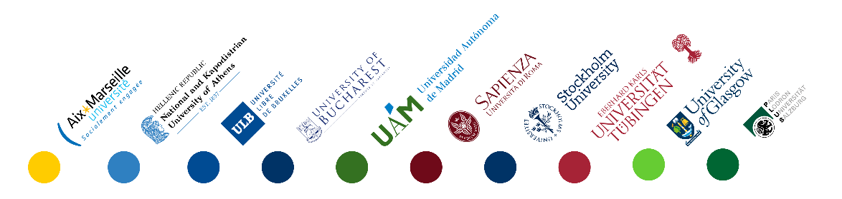
- Short essay (2,000 words maximum) in which the applicant will offer a personal answer to the question “How are the medical humanities important to the 21st Century?” – in English

