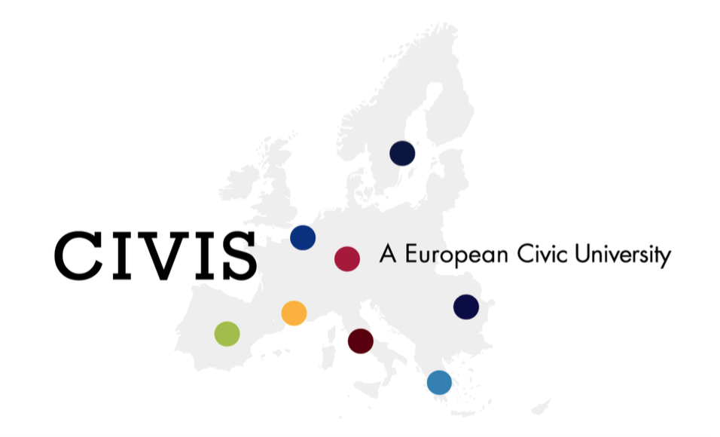

Application form
CIVIS Short Term Mobility Course

European citizenship and rhetorical argumentation: the case of climate change

All applications must be accompanied by :
- a curriculum vitae
- a cover letter

All documents (application form, CV and cover letter) must be sent to civis.ulb.amu.unibuc@gmail.com by May 31 2021 the latest.

All lectures, seminars, works and activities will be in English and all applicants must be fluent [B2] in speaking in English.

For any enquiries, please contact us at civis.ulb.amu.unibuc@gmail.com

PERSONAL DETAILS

First Name : ………………………………………………..
Name : ……………………………………………………….
Nationality : …………………………………………………
Date of Birth : ………………………………………………
Permanent Adress : ……………………………………….
…………………………………………………………………
…………………………………………………………………
Email : ………………………………………………………..

EDUCATION AND QUALIFICATIONS

Year and level of Study : …………………………………
Major : ……………………………………………………….
Institution attended : ……………………………
Most recent diploma obtained : ………………

Languages spoken (& level): 1) ………………………….
2) ………………………….
3) ………………………….
+ …………………………..

For any enquiries, please contact us at civis.ulb.amu.unibuc@gmail.com

